Website

# Home

1. Header



1. Once Hove at تسجيل دخول Display This Sub-menu

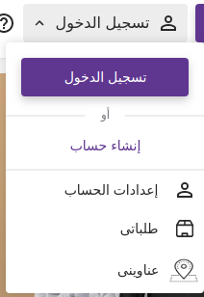

1. Once Click on Sidebar Icon From Header Show Sidebar By This Method (Souaq),

* 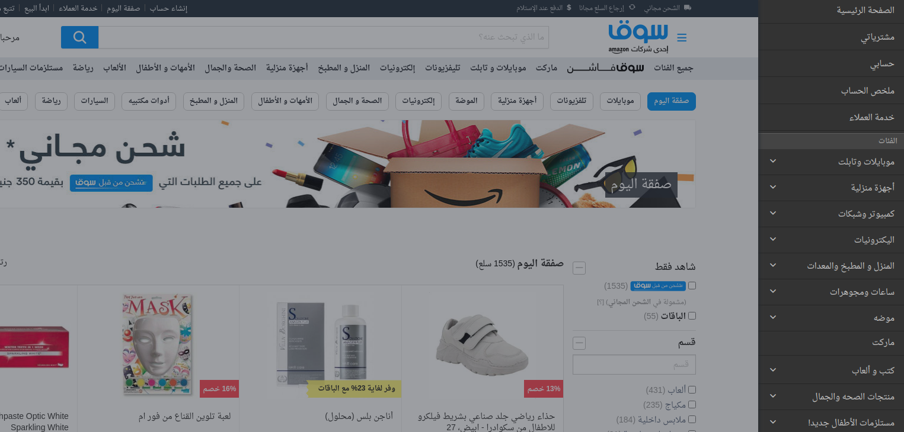Main Sidebar Items (الرئيسية, الأنظمة الغذائية, التصنيفات, إعدادات الحساب, تغيير اللغة)

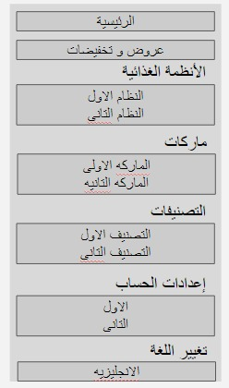

* Once click on item open sub-menu 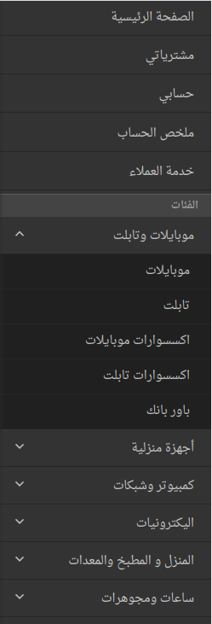which contain sub item

1. Navbar

once open hover at any item at navbar and it has sub items, display it at sub-menu

1. Make background of body of website #F5F5F5
2. Display Every Block/Section at Home Page With This Style, but Keep on Product Cart (Look Like abuauf)

Category Name | description , عرض الكل

1. 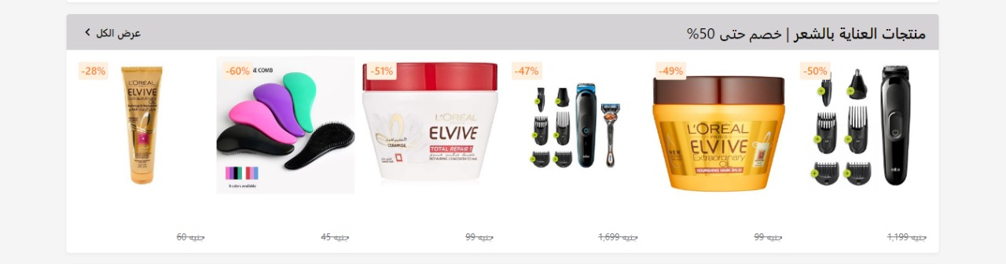Display Brands Section Look like Every Section but in Carousel, Once click on Brand open Page Contain All Products and Categories of this Brand

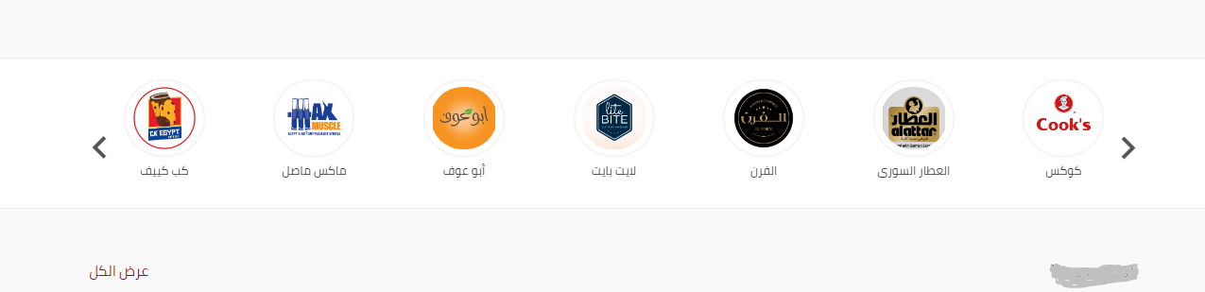

1. Footer

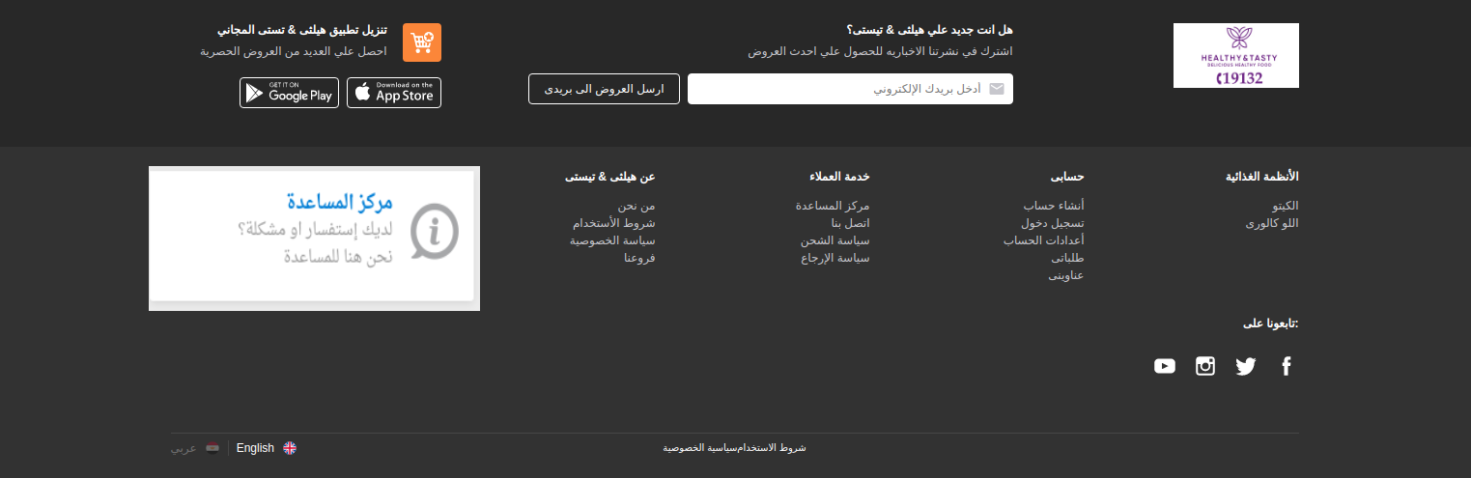

Admin Panel